# Name :Laraib Ayoub ROLL NO: 21SW120

**Task #1**

1. Write a program based on threads. Perform multi-threading and print even and such that when the numbers reach at value 30 then give a delay of 5 seconds. After the delay, the program will continue to print the series at the same manner

public class Task_1 extends Thread { public void run() {

for (int i = 0; i < 100; i++) { if (i % 2 == 0) {

System.out.println("even numbers are: " + i);

} if(i==30){

try {

Thread.sleep(5000);

} catch (Exception e) { System.out.println(e); }

}

}

}

}

class Demo {

public static void main(String[] args) { Task_1 thread = new Task_1();

thread.start(); }

}

# OUTPUT:-

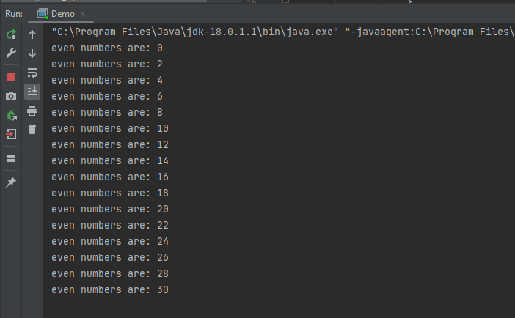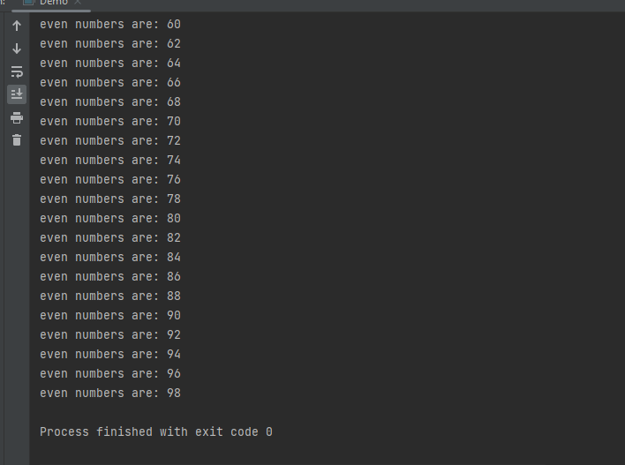

**Task #2**

Create three classes, Storage, Counter, and Printer. The Storage class should store an integer. The Counter class should create a thread that starts counting from 0 (i.e. 0,1, 2,3,4….) and stores each value in the Storage class. The Printer class should create a new thread that keeps reading the value in the Storage class and printing it

import java.lang.Runnable; class Storage {

private int num;

public Storage(int Num) { num=Num; } public int GetX() { return num ; }

public Storage(Storage s) { this.num = s.GetX(); }

}

class Printer implements Runnable{ private Storage storage;

Printer(Storage s) { storage = new Storage(s); } public void run(){

System.out.println(storage.GetX()); }

}

class Counter implements Runnable

{

private int N;

public Counter(int n) { N=n; }

public int GetN() { return(N); } public void run()

{

for (int i=1; i<=N; i++)

{

Storage storage = new Storage(i); Printer printer = new Printer(storage); Thread.yield();

printer.run();

}

}

}

class ThreadCounter{

public static void main(String args[]){ Counter counter = new Counter(50);

counter.run(); }

}

# Output:

